|  |  |  |  |  |  |
| --- | --- | --- | --- | --- | --- |
| Date | Sept 6, 2022 | | | Tester Name | Alyssa Johnson |
| Environment | Penfax - Test | | | Login used |  |
| Operating System | Select OS | Version: | Update: | | |
| Software Used | Select Software | Version: | Update: | | |
| Select Software | Version: | Update: | | |
| Release version | 22.3.0 | | | | |
| Title | E26.07 | | | | |
| Test Type | Regression | | | | |
| Test Scenario | Verify the Interfund (PEPP & VPB) confirmation letters are NOT generated for the system produced transfers/changes by DC live cycle batch. | | | | |
|  |  | | | | |
| Expected Results | Interfund confirmation letters are NOT generated on several members (check both PEPP and VPB) | | | | |
| Pass/Fail | Pass | | | JIRA# | N/A |

To find a member that was processed in yesterday’s Life cycle batch.

Batches/Batch processed & search PEPP valuation report:

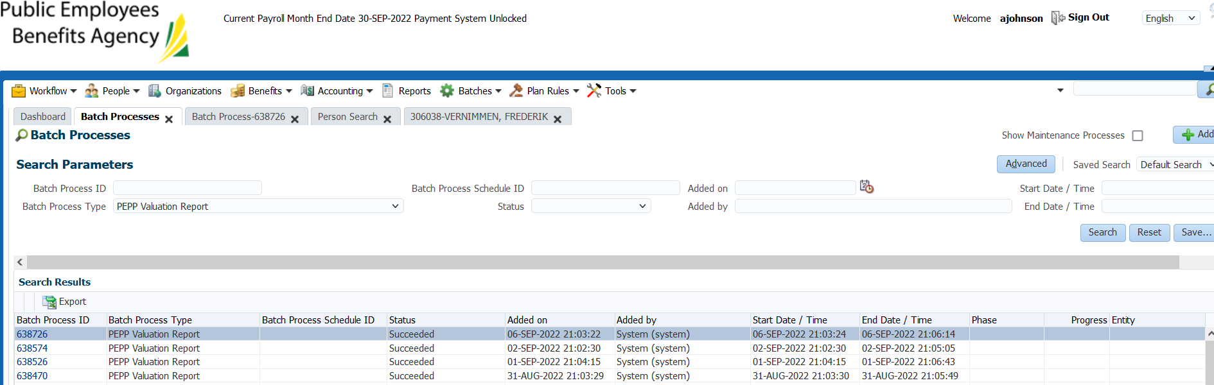

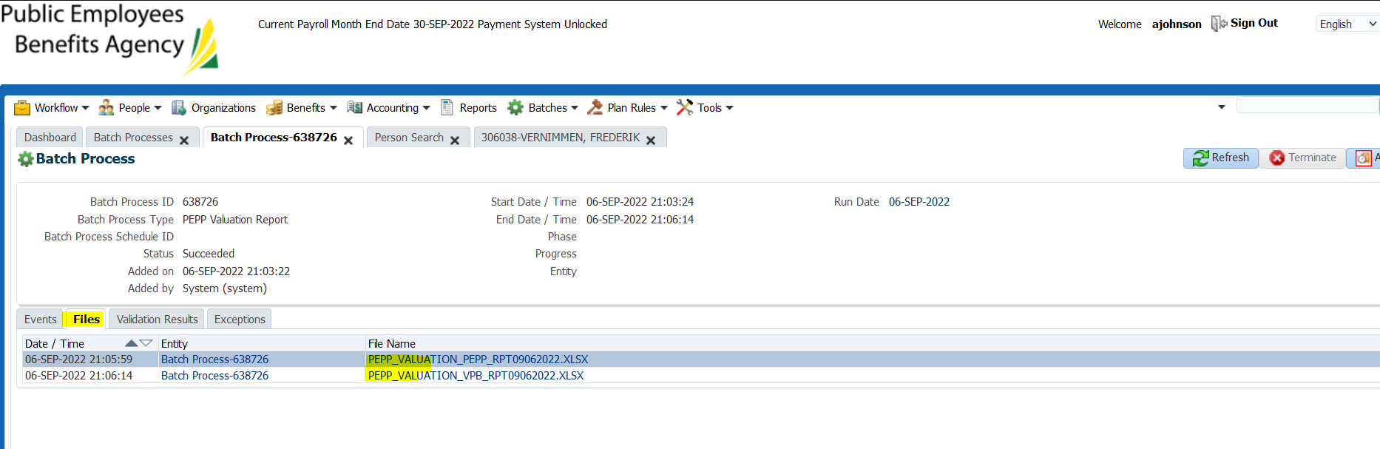

Open the file and look at section 4 to find any PEPP steps interfunds:

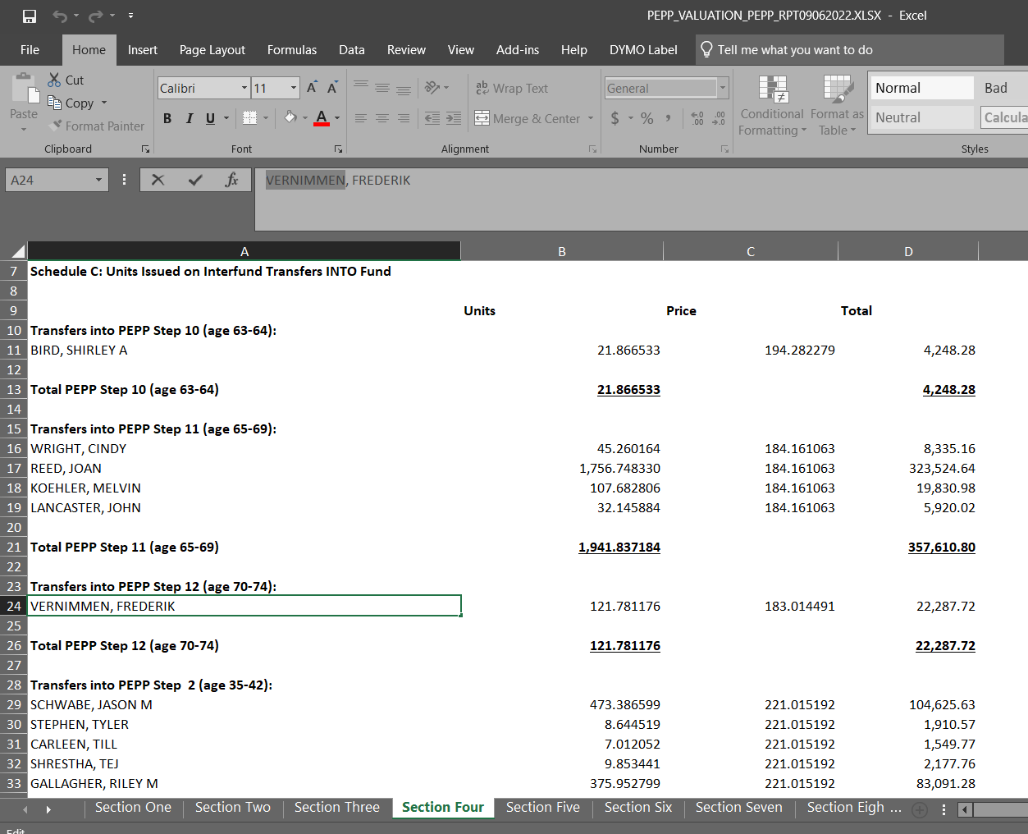

SID: 306038  
Confirm the interfund was processed to move PEPP steps  
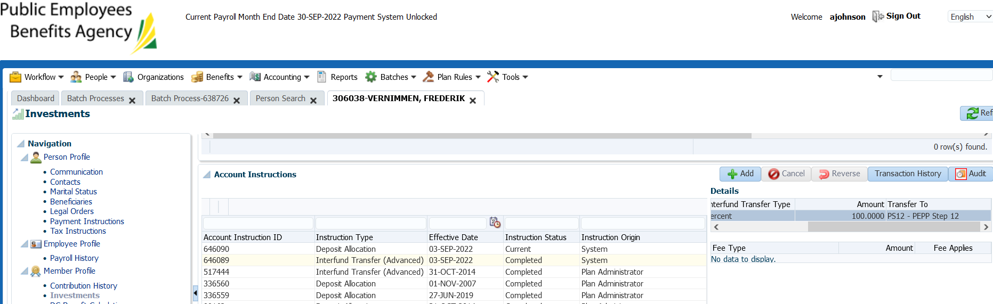

Confirm no letter generated in communication tab (the communications tab is missing inbound & outbound documents):

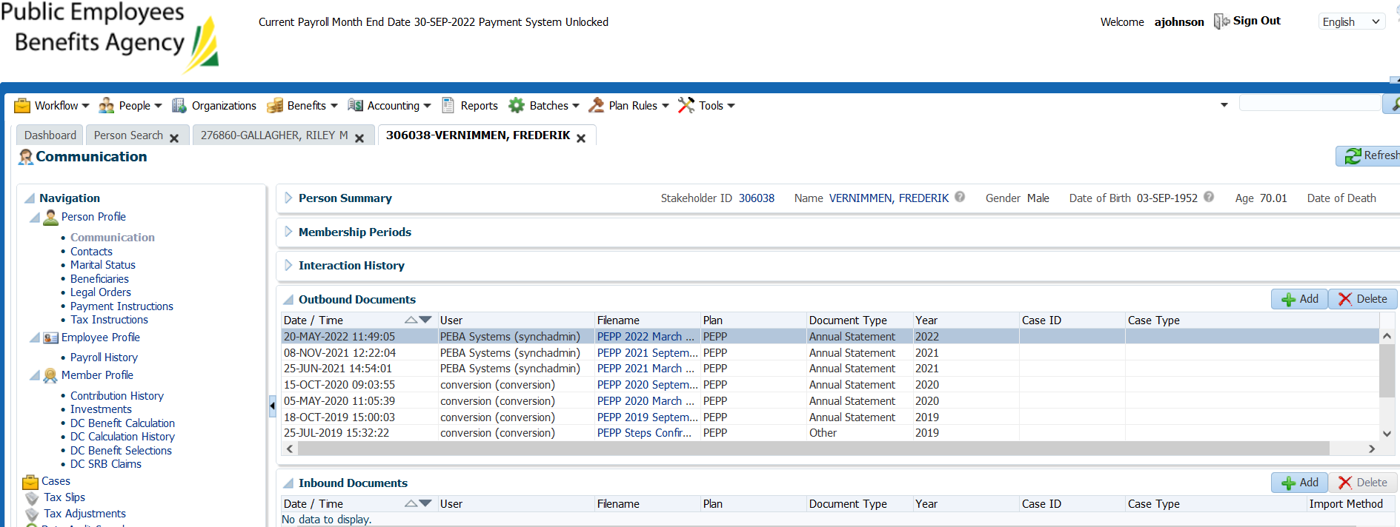

No letter generated – ticket passed

Noticed the following (apart from this test case):

The view when opening the communications tab is different, it’s showing an interaction history that isn’t in production.

PEBA 921 – ticket that requested the interaction history to be hidden (for some reason it’s no longer hidden on this release). Pana is following up on this with Jeroen to ensure that this is hidden when the release goes live.

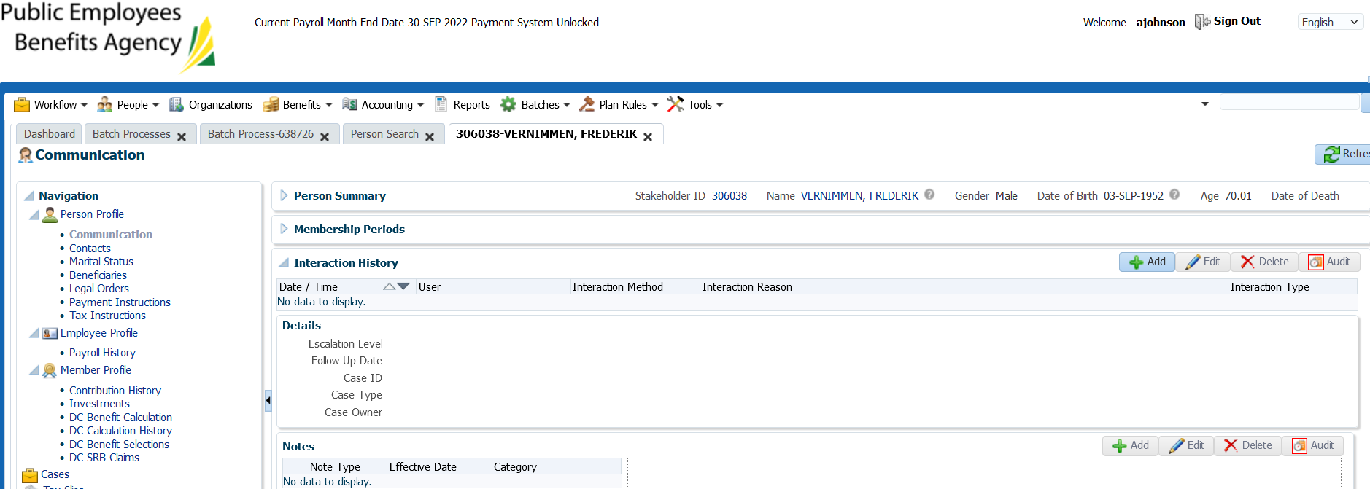

Production environment communications tab (to compare):

